TYPE YOUR TITLE HERE THE TEMPLATE HAS STYLES TO HELP FORMAT THE TITLE; STYLE NAMES ARE: “TITLE ONE-LINE” ETC

A Thesis

Presented to

The Faculty of the Type in Name of Department or School

San José State University

In Partial Fulfillment

of the Requirements for the Degree

Type of Degree, e.g., Master of Arts

by

Type Your Name Here

December/May/August (Month varies on graduation semester) Year

© Year

Type Your Name Here

ALL RIGHTS RESERVED

The Designated Thesis Committee Approves the Thesis Titled

TYPE IN TITLE OF THESIS HERE

by

Type Your Name Here

APPROVED FOR THE TYPE IN NAME OF DEPARTMENT OR SCHOOL

SAN JOSÉ STATE UNIVERSITY

December/May/August (Month varies on graduation semester) Year

|  |  |
| --- | --- |
| Faculty Name, Ph.D. | Type in Name of Department or School |
| Faculty Name, Ph.D. | Type in Name of Department or School |
| Faculty Name, Ph.D. | Type in Name of Department or School |

Your 3rd committee member may be from outside of SJSU. Place the committee member’s name followed by the highest degree the committee member holds e.g. Jan Smith, MA; Jan Smith, Ph.D. etc. If the third committee member is outside of SJSU, list the department name, and indicate their title, and where they work (teach) in the field to the right of their name and title. For example: Jan Smith, MA. Director, School of Information, University of Arizona. **Do not forget to delete these instructions.**

ABSTRACT

TYPE IN YOUR THESIS TITLE HERE

by Your Name as it Appears on the Title Page

Type in your abstract here. It must be indented 0.25” and consist of a single paragraph. This page is mandatory and must fit on one page. The abstract is a brief, comprehensive summary of the contents of the thesis. The abstract may not contain source documentation (citations). Replace these instructions with your text.

ACKNOWLEDGEMENTS

This page is optional. Insert your acknowledgements text here. Page numbers start on page v.

TABLE OF CONTENTS

List of Tables #

List of Figures #

List of Abbreviations #

1 Introduction( Using Section Title) 3

1.1 Heading 3

1.1.1 Heading 3

References 3

1. Title of Appendix 3

**YOU MUST MANUALLY ENTER A TAB CHARACTER AFTER THE DOT LEADER AND BEFORE THE PAGE NUMBER FOR EVERY LINE ITEM ON THE TOC.** This will make the page number alignment match the preliminary page TOC line items.

**Note: You must use one of the approved SJSU Table of Contents formats. Please refer to the SJSU approved preliminary pages for Table of Contents examples.**

**You can modify the heading styles to fit your required formatting.**

**Fourth level headings will not autogenerate in the ToC. If you wish to include fourth level headings, then you will need to place them in by hand.**

The Appendix column heading and preliminary page numbers (in lowercase Roman numerals) will need to be typed in manually, they will not generate automatically as part of the Table of Contents. Add both items manually after generating the Table of Contents. See the “Generating a Table of Contents in the Template” guide on our website for additional help. Also, don’t forget to delete these instructions!

LIST OF TABLES

Table 1. Sample of a One-Row Table: Apply the Table Title Style in Text for Easy Formatting 3

**Add two tabs between the table number and the table title for proper formatting. Add a tab after the dot leader and before the page number. Delete these instructions.**

LIST OF FIGURES

Figure 1. SJSU Tower Lawn. Applying the Caption style will help you update the List of Figures automatically. This includes matching text and the correct page number. 3

Figure 2. SJSU thesis template styles. Apply the Caption style in text for easy formatting. 3

**Add two tabs between the figure number and the figure caption for proper formatting. Add a tab after the dot leader and before the page number. Delete these instructions.**

LIST OF ABBREVIATIONS

This page is optional. Type in your list here in alphabetical order. Apply the “Single-spaced Text” Style. Don’t forget to delete these examples and instructions.

CUCA – Cornell University’s College of Agriculture

DOD – US Department of Defense

ELHS – East Lansing High School

RNA - ribonucleic acid

snRNA – small nuclear ribonucleic acid

SI units – System of International Units (*Système international d'unités*)

1 Introduction( Using Section Title)

If you haven't done so already, read your style guide approved by your department (example APA, Chicago, MLA) for proper formatting.

There are many styles included in this template designed to make your formatting easier. For example we have created A SECTION style that will help you automatically generate your Table of Contents. Applying the Section Label style will also begin the chapter on a new page.

# 1.1 Heading

Here’s an example of what a Heading 1 might look like. This template has linked the Heading 1 and Heading 2 styles to the TOC so that they will automatically appear when you generate your Table of Contents.

* Lists are double spaced and followed by normal text spacing.
* Here is an example of a bullet list that wraps past 1 line. Here is an example of a bullet list that wraps past 1 line. Here is an example of a bullet list.

1. Lists are double spaced and followed by normal text spacing.
2. Here is an example of a numbered list that wraps past 1 line. Here is an example of a numbered list that wraps past 1 line.

Figure 1 and Figure 2 in this document are included so that you can see an example of the List of Figures. The same is true for Table 1. Figures and tables must be referenced in text prior to their inclusion. They should be placed as close to the first reference to them as possible, at the end of a paragraph. If there is not enough space on the page where the item is

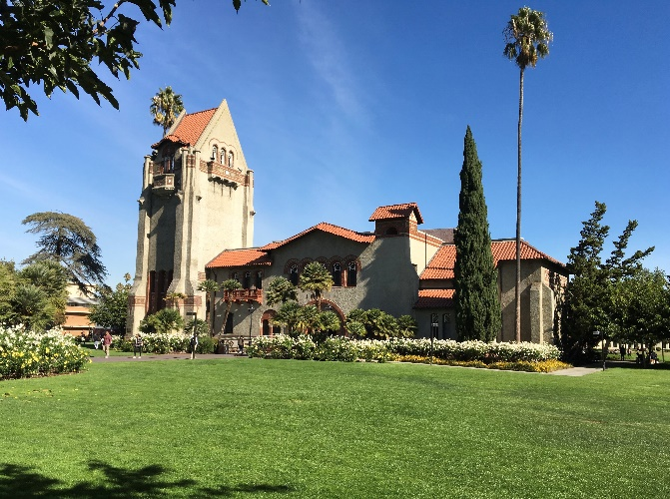

Figure 1. SJSU Tower Lawn. Applying the Caption style will help you update the List of Figures automatically. This includes matching text and the correct page number.



Figure 2. SJSU thesis template styles. Apply the Caption style in text for easy formatting.

Table 1.  
Sample of a One-Row Table: Apply the Table Title Style in Text for Easy Formatting

|  |  |  |  |  |
| --- | --- | --- | --- | --- |
| Sample Location | # of Samples | Type of Fungi | Relative Humidity, Temperature | Sampling Time |
| Environmental Chamber | 40 | *Aspergillus niger* | 50%, 25C | 3 minutes |

Note: Most tables will have more than one row; the purpose here is to show the table title.

introduced, continue filling that page with text and start the table or figure at the top of the next page. The selected style guide shall govern table and figure titles, and table and figure numbering. If the style guide does not list formatting instructions for these items, the student must place table titles above the table and figure titles below the figures. The thesis template styles make formatting these sections easy. Simply apply the correct style to the desired text and update the field in the preliminary pages. Figures use the Caption style and Tables use the Table Title style. **Note: You must refer to your department style guide for proper formatting. If your style guide requires specific formatting for tables and figures, then you may need to modify the template Caption and Table Title styles accordingly.**

Pages are provided in this template for the post-text sections, i.e., References, and Appendix (if you have appendices), just as they are for the preliminary page sections. Two pages formatted in LANDSCAPE orientation are also provided, but in a separate template document (*SJSU Template Landscape Pages*).

## 1.1.1 Heading

Here’s an example of a Heading 2. Remember to be consistent when formatting each heading level.

We have created an Equation style to help you center equations on a page and right align equation numbers. Here’s an example of an equation:

$x=\frac{−b±\sqrt{b^{2}−4ac}}{2a}$ (1.1)

Here is what a block quote looks like when you apply the Block Quotation style:

Direct quotations must always be documented with the correct source information and page number. Indirect citations (paraphrasing) must be documented in text but page numbers are optional unless your department style guide requires page numbers for this purpose. For example, the *MLA Handbook* requires page numbers for both direct and indirect citations. See your style guide for the correct format of source documentation. (p. 66)

1.1.1.1 Heading: Type fourth level headings in by hand as normal text. The fourth level heading uses sentence case capitalization.

If your manuscript is already written/partially written, and you want to start using the template, you may perform a subdocument import to maintain the template integrity. See the Subdocument Import guide for detailed instructions. Note that the “copy and paste special” option has limitations. **Don’t forget to delete these examples.**

References

Insert your source documentation **according to your departmental style guide** with the exception of single spacing each entry and using normal line spacing between entries. Both versions of the Hanging Indent style (examples shown below) are included in this template

**HANGING INDENT** (formatted according to APA here, but you must follow *your* departmental style):

Eco, U. (2015). *How to write a thesis*. MIT Press.

Moll, L. C. (2000). Writing as communication: Creating strategic learning environments for students. *Theory into Practice, 25*(3), 202-208.

**HANGING INDENT AUTHOR/NUMBER** (formatted according to IEEE here, but you must follow *your* departmental style):

[1] S.M. Hemmingen, *Soft Science*. Saskatoon: University of Saskatchewan Press, 1997.

[56] G. Liu, K.Y. Lee, and H.F. Jordan, “TDM and TWDM de Bruijn networks and shufflenets for optical communications,” *IEEE Trans. Comp.*, vol. 46, pp. 695-701, June 1997.

Delete the contents of this page (except for the title) and apply the appropriate hanging indent style to your entries.

Appendix

Title of Appendix

Insert your appendix material here. When you apply the APPENDIX LABEL and APPENDIX TITLE style to this section the template will automatically add the Appendix Title to the TOC (you will have to add the Appendix Label to the TOC manually). Applying the Appendix Label style will also begin this section on a new page. **Don’t forget to delete these comments.**